Course Title: Cryptography and Network Security Lab | Course Code: BCSE309P
Faculty: Prof. Karthika V | Slot: L43 + L44
Regno: 23BCE1145 | Name: S Vishwajith

EX2A – S-DES

Code:

Sender:
import pickle
import socket

def circular_left_shift(s, n):
n = n % len(s)
return s[n:len(s)] + s[0:n]

def get_intermediate_keys(key, P10, P8):
key_new = ""
for i in P10:
key_new += key[i-1]
key_new = circular_left_shift(key_new[:5], 1) + circular_left_shift(key_new[5:], 1)
k1, k2 = "", ""
for i in P8:
k1 += key_new[i-1]
key_new = circular_left_shift(key_new[:5], 2) + circular_left_shift(key_new[5:], 2)
for i in P8:
k2 += key_new[i-1]
return [k1, k2]

def S_box(l, r):
S_0 = [["01", "00", "11", "10"],
["11", "10", "01", "00"],
["00", "10", "01", "11"],
["11", "01", "11", "01"]]
S_1 = [["00", "01", "10", "11"],
["10", "00", "01", "11"],
["11", "00", "01", "00"],
["10", "01", "00", "11"]]
return S_0[int(l[0] + l[3], 2)][int(l[1:3], 2)] + S_1[int(r[0] + r[3], 2)][int(r[1:3], 2)]

def exclusive_or(s1, s2):
res = ""
for i in range(len(s1)):
res += str(int(s1[i]) ^ int(s2[i]))
return res

def work(PT, EP, k_i, P4):
l_0, r_0 = PT[:4], PT[4:]
temp = ""
for i in EP:
temp += r_0[i-1]
temp = exclusive_or(temp, k_i)
temp = S_box(temp[:4], temp[4:])
l_1 = ""
for i in P4:
l_1 += temp[i-1]
l = exclusive_or(l_0, l_1)
return l + r_0

def encrypt(PT, key, P10, P8, P4, IP, IP_inv, EP):
PT_new = ""
for i in IP:
PT_new += PT[i-1]
k1, k2 = get_intermediate_keys(key, P10, P8)
print(f"\nThe subkeys are: {[k1, k2]}.")
print(f"The plain text after initial permutation: {PT_new}.")
PT_new = work(PT_new, EP, k1, P4)
PT_new = PT_new[4:] + PT_new[:4]
print(f"The plain text after Round 1: {PT_new}.")
PT_new = work(PT_new, EP, k2, P4)
print(f"The plain text after Round 2: {PT_new}.")
CT = ""
for i in IP_inv:
CT += PT_new[i-1]
return CT

def get_inverse_IP(IP):
IP_inv = []
for i in range(len(IP)):
IP_inv.append(IP.index(i+1)+1)
return IP_inv
print("S-DES sender initialized.\n")
PT = input("Enter the 8-bit plain text in binary: ")
key = input("Enter the 10-bit key in binary: ")
P10 = input("Enter the permutation for 10 bits: ").split(" ")
P8 = input("Enter the permutation for 8 bits: ").split(" ")
P4 = input("Enter the permutation for 4 bits: ").split(" ")
P10 = [int(i) for i in P10]
P8 = [int(i) for i in P8]
P4 = [int(i) for i in P4]
IP = input("Enter the initial permutation for 8 bits: ").split(" ")
IP = [int(i) for i in IP]
IP_inv = get_inverse_IP(IP)
EP = input("Enter the expansion permutation for 4 to 8 bits: ").split(" ")
EP = [int(i) for i in EP]

CT = encrypt(PT, key, P10, P8, P4, IP, IP_inv, EP)
print(f"The cipher text is: {CT}.")

s = socket.socket()
s.connect(('127.0.0.1', 5995))
s.send(CT.encode().ljust(1024, b'\0'))
s.send(key.encode().ljust(1024, b'\0'))
s.send(pickle.dumps(P10).ljust(1024, b'\0'))
s.send(pickle.dumps(P8).ljust(1024, b'\0'))
s.send(pickle.dumps(P4).ljust(1024, b'\0'))
s.send(pickle.dumps(IP).ljust(1024, b'\0'))
s.send(pickle.dumps(EP).ljust(1024, b'\0'))
print("\nThe Cipher text, key and the permutations have been sent successfully to the receiver.")
s.close()

Receiver:
import pickle
import socket

def circular_left_shift(s, n):
n = n % len(s)
return s[n:len(s)] + s[0:n]

def get_intermediate_keys(key, P10, P8):
key_new = ""
for i in P10:
key_new += key[i-1]
key_new = circular_left_shift(key_new[:5], 1) + circular_left_shift(key_new[5:], 1)
k1, k2 = "", ""
for i in P8:
k1 += key_new[i-1]
key_new = circular_left_shift(key_new[:5], 2) + circular_left_shift(key_new[5:], 2)
for i in P8:
k2 += key_new[i-1]
return [k1, k2]

def S_box(l, r):
S_0 = [["01", "00", "11", "10"],
["11", "10", "01", "00"],
["00", "10", "01", "11"],
["11", "01", "11", "01"]]
S_1 = [["00", "01", "10", "11"],
["10", "00", "01", "11"],
["11", "00", "01", "00"],
["10", "01", "00", "11"]]
return S_0[int(l[0] + l[3], 2)][int(l[1:3], 2)] + S_1[int(r[0] + r[3], 2)][int(r[1:3], 2)]

def exclusive_or(s1, s2):
res = ""
for i in range(len(s1)):
res += str(int(s1[i]) ^ int(s2[i]))
return res

def work(PT, EP, k_i, P4):
l_0, r_0 = PT[:4], PT[4:]
temp = ""
for i in EP:
temp += r_0[i-1]
temp = exclusive_or(temp, k_i)
temp = S_box(temp[:4], temp[4:])
l_1 = ""
for i in P4:
l_1 += temp[i-1]
l = exclusive_or(l_0, l_1)
return l + r_0

def decrypt(CT, key, P10, P8, P4, IP, IP_inv, EP):
CT_new = ""
for i in IP:
CT_new += CT[i-1]
k2, k1 = get_intermediate_keys(key, P10, P8)
print(f"\nThe subkeys are: {[k1, k2]}.")
print(f"The cipher text after initial permutation: {CT_new}.")
CT_new = work(CT_new, EP, k1, P4)
CT_new = CT_new[4:] + CT_new[:4]
print(f"The cipher text after Round 1: {CT_new}.")
CT_new = work(CT_new, EP, k2, P4)
print(f"The cipher text after Round 2: {CT_new}.")
PT = ""
for i in IP_inv:
PT += CT_new[i-1]
return PT

def get_inverse_IP(IP):
IP_inv = []
for i in range(len(IP)):
IP_inv.append(IP.index(i+1)+1)
return IP_inv

server = socket.socket()
server.bind(('127.0.0.1', 5995))
server.listen(1)
print("S-DES Receiver initialized and listening for sender.")
conn, addr = server.accept()
print(f"Connection established with sender at {addr}.")

CT = conn.recv(1024).decode().rstrip('\0')
print(f"The received cipher text is: {CT}.")
key = conn.recv(1024).decode().rstrip('\0')
P10 = pickle.loads(conn.recv(1024).rstrip(b'\0'))
P8 = pickle.loads(conn.recv(1024).rstrip(b'\0'))
P4 = pickle.loads(conn.recv(1024).rstrip(b'\0'))
IP = pickle.loads(conn.recv(1024).rstrip(b'\0'))
IP_inv = get_inverse_IP(IP)
EP = pickle.loads(conn.recv(1024).rstrip(b'\0'))

conn.close()
server.close()

PT = decrypt(CT, key, P10, P8, P4, IP, IP_inv, EP)
print(f"The plain text is: {PT}.")

Output:

Sender:
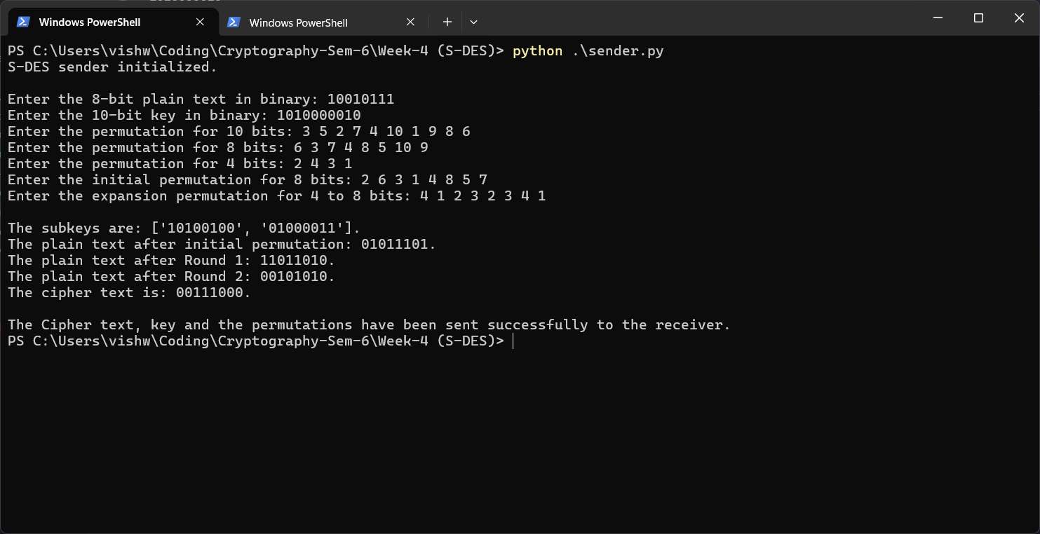

Receiver:
